FULL TERM CARGO SHIP SAFETY RADIOTELEPHONY CERTIFICATE

VESSELS UNDER 300 GRT

Issued under the authority of the Government of

THE MERCHANT MARINE HONDURAS

By GR CLASS CLASSIFIED FOR STANDARD (GR CLASS)

SARCE No.
Name Ship | Type | Distinctive number or letters | Port of registry | Gross tonnage | Keel laid
 |  | IMO Number:

This is to certify that the radio telephony equipment of the aboved mentioned ship has been surveyed in accordance with the Regulations in force of the said Government and has been found in accordance with the requirements of said Regulations.

The equipment installed as required in the rules is:

Equipment | Required | Installed
Radiotelephone Station
VHF Radiotelephone
Portable radio apparatus.
E.P.I.R.B.

The radiotelephone distress frequency (2182 kHz) shall be monitored on a continuous basis or, if a radiotelephone station is not installed on board, the VHF channel 16. If radiotelephone station is installed on board, at least one member of the crew must be in possession of valid Radiotelephone Operator Certificate.

The undersigned declares that he is duly authorized by the said Government to issue this certificate.

Issued at | Date of issue
(Place of issue of certificate) |  | (DD-MM-YYYY)

This certificate is valid until
(DD-MM-YYYY)

GR CLASS REPRESENTATIVE

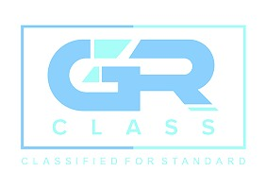

GR CLASS – CLASSIFIED FOR STANDARD (GR CLASS)
E-mail: info@grclass.com Web: www.grclass.com

Form SARCE-FT Approved by: GM Page 1 of 1

